Assignment1

ICT 116 Design Thinking

Choose an existing design (A product or service, could be an object, interactive design or a

digital tool) and apply the human-centred design methodology learnt in class to analyse the

problem that was designed to resolve. Research the problem through techniques such as

interviewing, storyboarding and sketchnoting. Explain how the design elements and

principles have been used? Does the design effectively fulfil the identified need? Why?

Identify any areas of opportunity for improvements. Research must include referencing in

APA format.

Answer:

The existing design which I choose is PlayStation 5 which is a gaming console introduced by the Sony interactive and it was introduced to users and released in November 2021. It has become huge revolution in gaming world.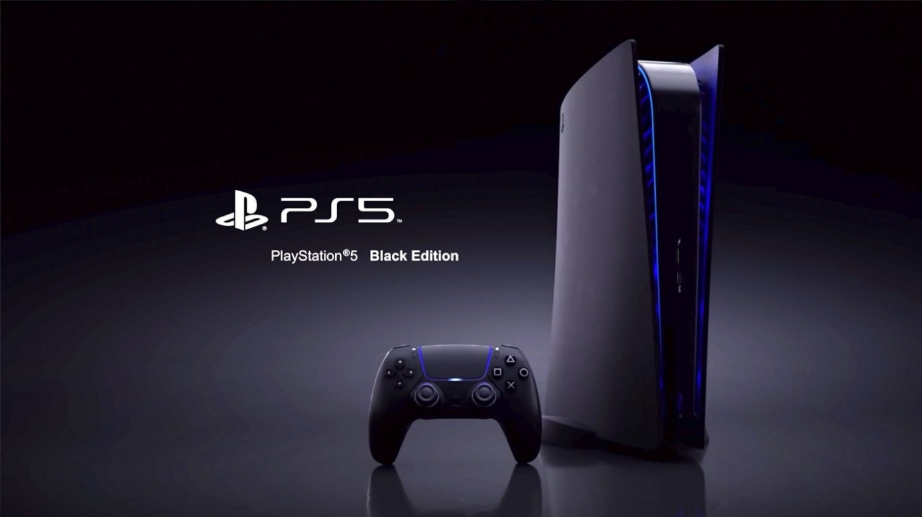

Preparation of Interview questions

* Do you know about Sony’s PlayStation- ?
* What the most features you like about this gaming console?
* Are there any reasons you are using the console?
* Do you feel more comfortable and satisfied while playing in this console?
* What difficulties you face while playing in this console?
* Is there any features in this console that makes so special?

Answers to the interview question:

I have gaming enthusiastic since my childhood, so I always feel more satisfied while playing the games which had made me stress free and I also review people opinion towards this gaming. As we all know this console is known in worldwide and is known as for Revolutionize console. But specially I came know about this amazing console through my friends who were using previous model of this console and they were planning to get this new console which was released. They mentioned that this new console has got the best features and playing in this console can get more entertainment and more content to watch and play. As per him he said that the newer version of this PlayStation has made them feel more realistic while playing the game.

Problem statement:

As this designed was developed by the Sony’s organisation to address the evolving needs and desire of gamers while the problem it as meant resolve was to provide a more immersive and powerful gaming experience to players out there. While in today’s era the games which are released and about released are more complex and has demand of higher graphical fidelity, Faster processing, and seamless interaction. So there need for next generation gaming console to meet those requirements. Another problem in this gaming console is Heating problem which also main problems for gamers out there. And console crashing has also given lots of frustration to the gamers.

Using human-centered design methodology learnt in class to analysize the problem that was designed to resolve.

Stage 1: Empathize

Human-centred design methodology has played a vital role in shaping the design that user was desperate to get console design. The team member in designing came to a point by understanding the problem and need of the gamers so that they can create a console which can reverberate with users on profound level. During this empathize stage many developers were assigned to interview with games for different background to get result of their in-gaming habits, preferences , aspirations, and frustration they while playing the games. This information provided a better understanding of what games want while playing a game.

In this process they have also observed in their natural environments about how they have been interacting with existing consoles which has can help in identifying main point and issues that could help in PS5 design. While still most feedback got from online, and surveys done by the team has provided additional supports into trends, preferences, and areas pf dissatisfaction. Through the surveys and research, the team has craved for more immersive experience with realistic graphic and more approachable controls with faster load times and smother interactions and quick access to games without any delays.

Stage 2: Define

Designers has combined the information from the previous phase in the define phase to pinpoint the main obstacles and possibilities which might entail identifying the essential features and capabilities that player want for the PS5. Backwards compatibility has enhanced user interfaces, and strong hardware enabling cutting-edge graphics are few examples of such elements.

Stage 3: prototype

It has been clearly focused on coming up with several thoughts and ideas where designers would come up with creative answer to the problems they had identified while researching and surveys. In the terms of the PS5, this phase would entail creating design concepts in sketches, testing with hardware setups, and thinking of innovative methods to improve gameplay and user interaction.

While making prototype it is essential during this stage of development. Models or interactive prototypes of console physical design and user interface might be made by developers. These prototypes enable testing and iteration which ensures the finished product complies with the requirements of the user and the design objectives.

Stage 4. Testing

The selected concept is turned into a fully working product during the Testing phase. Finalising the design, designing the hardware, and creating the software ecosystem are all part of this process for the PS%. To ensure the smooth integration of hardware and software components, designers would work with manufactures and developers. While in this testing phase is critical for user experience design. It is essential that user interface, menu system and interaction design be simple and easy to use. To create a compelling and refined user experience, this entails iterative testing.

Several key design and elements

* Custom CPU, GPU, and lightning-fast SSD Storage have significantly improved performance of the console.
* The Ecosystem Integration which permits unrestricted content exchange and improves the game experience was greatly aided by the PlayStation Plus and PlayStation store.
* Installation of next-generation hardware such as custom AMD CPU and a fast SSD.
* In the gaming industry, a design with aggressive curves with a two-tone colour palette and streamlined line has shown to have futuristic aesthetics.
* Backwards Compatibility was created to provide access to games from earlier generations.

Effectively fulfilling the needs

Gamers are happy because of next-generation technology with strong hardware and increased visual capabilities. Especially features like multiplayer or online capabilities, it has become ever more socially improved where many players are linked or communicating with one another. Hence the features that are available in this console has brought positive response within users and organization.

Areas of improvement

With this advanced technology which is used in this console there is still a lot of improvement needed to get more positive response from user. Where immediate improvement should made in heat control where there can be lots of measures can be applied such as liquid coolers like which are used in PC gaming and because of this it can help in this process of cooling the console. Accessibility must be improved so that person with disabilities may utilise more services and make environment more inclusive. There should be more distribution in the market since there has been lot shortage of console among consumers which has created of lots of frustration in the gaming users.

Conclusion

By implementing the principles of human-centered design, PlayStation 5 have successfully address the crucial problems and improving with more advanced tech like customized and fast SSD storage. The design of PS5 is still evolving and entirely driven by User feedback. It responds by emphasising user-centric design for next generation gaming. User’s gaming experience have been greatly improved by the hardware and DualSense controller. The PlayStation 5 is an example of how human-centered design ideas may be used effectively. Sony has developed a system that delivers an immersive and engaging gaming experience by comprehending the requirements and desires of gamers and developing a product that satisfies those demands via unique design components.

References

* *The PS5 Is Starting to Look Like the Revolution It Promised*. (n.d.). Wired. <https://www.wired.com/story/playstation-5-six-months-later/>
* ‌Kwok, B. (2021). *STUDY ON GAMING CONSOLES HEAT MANAGEMENT*. <https://scholarworks.calstate.edu/downloads/rj430979q>
* *PlayStation 5 is coming | Sign up for PS5 details*. (n.d.). PlayStation. <https://www.playstation.com/en-au/ps5/>